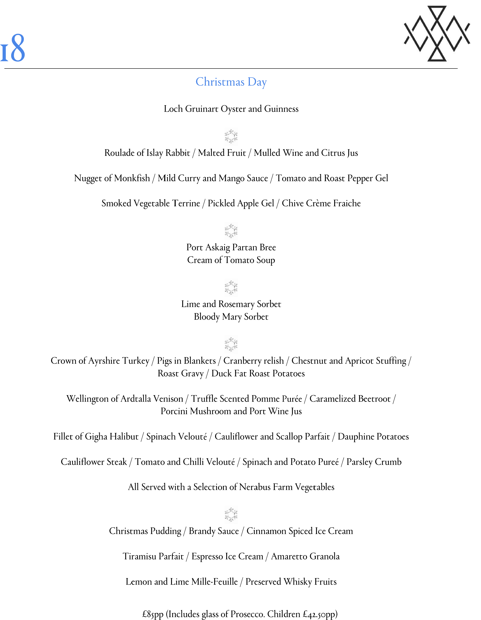
You should always advise your server of any special dietary requirements, including intolerances and allergies. Where possible, our trained staff will advise you on alternative dishes. However, while we do our best to reduce the risk of cross-contamination in our restaurant, we CANNOT guarantee that any of our dishes are free from allergens and therefore cannot accept any liability in this respect. Guests with severe allergies are advised to assess their own level of risk and consume dishes at their own risk.

